# Docker for .NET Developers

<https://www.youtube.com/watch?v=a8Z3MncihLg>

<https://solliance.net/>

.NET Developer Benefits

* Run .NET Framework applications in Windows containers
* Limited changes
* Encapsulate configuration and dependencies
* Refactor the monolith at your own pace
* Create new dotnetcore/ aspnetcore applications
* Target Linux orWindows containers
* Familiar development experience / debugging

**IIS Dockerfile**

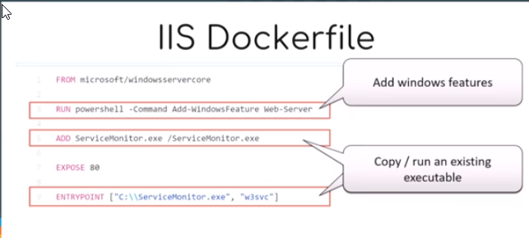

**ASP.NET 3.5 Dockerfile**

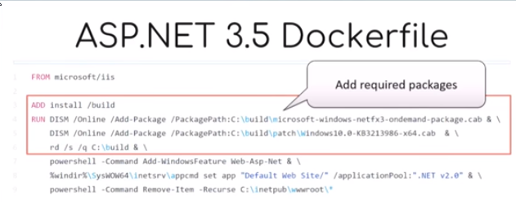**ASP.NET 4.6.2 Dockerfile**

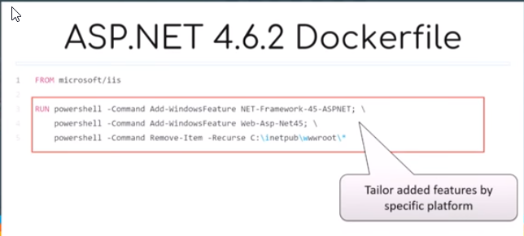

# **Container Images:**

Base images in Docker store. <https://store.docker.com>

# **Docker for windows. Developer Tools:**

* PowerShell
* Docker CLI
* Visual Studio 2017

Development Considerations:

Targert environments and base image

Debugging

Access to logs

Service depnedencies and netowrking

Environment Variables

CICD workflows

2. Documentation from microsoft docs.

<https://docs.microsoft.com/en-us/dotnet/architecture/containerized-lifecycle/design-develop-containerized-apps/visual-studio-tools-for-docker>

<https://docs.docker.com/docker-for-windows/>

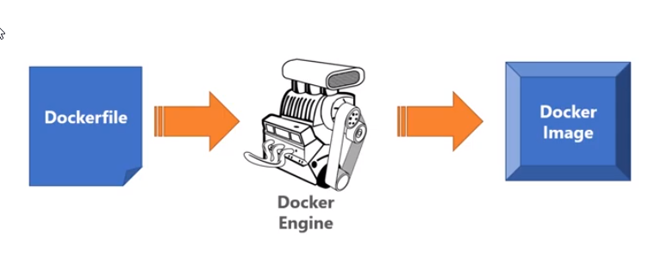

Youtube videos:

<https://www.youtube.com/watch?v=HxXs9_ggBfg>

<https://www.youtube.com/watch?v=p8cAYgBIER8>

